(1) Introduction
Welcome Facilitators
How to use the Guide
(2) Technical Information
Basic Functions
The Menu Bar
Space Setup
(3) JEDI Journey Facilitator Tips
Workshop Setup
Team Setup
Preparation
Technical Troubleshooting
Hacks for Group Facilitation in topia
(4) The world
Station 0: Basecamp
Station 1: Welcome to topia - A JEDI Experience
Station 2: Celebrating at the Intersections
Station 3: Reflecting Privilege
Station 4: Discovering our Blind Spots
Station 5: The Power of Words
Station 6: Action Planning
(5) Annex
Related links
Who is Deutsche Chorjugend?
Who is mediale pfade?
Who is Play for Peace?

1. Introduction

Welcome Facilitators
Welcome to Your JEDI Experience on topia, an avatar-based spatial platform with proximity video chat! This guide is designed to provide choir leaders around Germany and the world with a JEDI (Justice, Equity, Diversity, and Inclusion) experience for the young people they work with. This guide was developed by the Play for Peace Community in cooperation with mediale pfade and the German choir youth to support others who also want to create a more peaceful world. Please review this guide carefully in advance of leading participants through the experience. And if possible, practicing the experience beforehand would be helpful.

How to use the Guide
Facilitating workshops in topia is fun but also challenging. This guide is meant to support and equip you with the necessary technical knowledge and tips for working with groups in topia.
For the technical set-up please go through the tutorial which is located directly in the topia main world topia.io/chorleben. It provides you with information on the different functions and assets in the world. The basic functions are briefly explained here as well, however, we strongly advise you to get familiar with the platform and its functions directly in topia before facilitating your workshop.
Please make sure to read the information about how to facilitate in topia. It provides you with information on how to set up your team, how to communicate with groups verbally and non-verbally, how to guide groups, how to use tools, etc.
The main part of this guide leads you through each station step by step. Feel free to adapt the methodology according to your group, objectives, and experience.
In the last section, you will find additional information on the topic of JEDI.

2. Technical information
Topia is an avatar-based spatial platform with proximity video chat. As you walk near other avatars, their video and sound will fade in. This allows a much more flexible and interactive workshop set-up than Zoom or similar tools.
Please note that the topia experiences and interactions work best with the Chrome browser on a laptop or desktop computer. It is, however, possible to use tablets or iPads as well, here ideally with the Chrome browser as well.
It is highly recommended that all participants use headphones and microphones for a better user experience.

Basic Functions
The best, easiest, and most fun way to learn about the basic functions in topia is our interactive tutorial in the Chorleben world. However, here is a short overview of the most important functions.

Moving around in topia

There are two possible ways of walking in the topia world:
- Click in the direction you would like to go.
- Use the arrow keys to move.
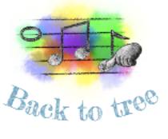
To travel long distances, you can use the loopholes that teleport you to another place in the same world.

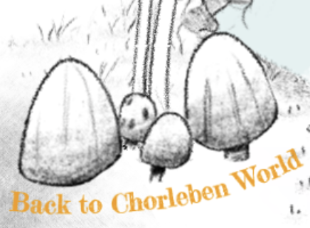
To get from one world to another, use the portals. They work similarly to the loopholes.
Both loopholes and portals are labeled with their destination.

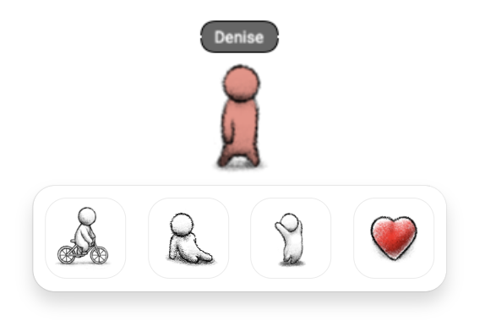
Moving your avatar
Your avatar - or topi - can sit, dance, and shout out heart emojis. In order to do so, click on your topi and you will see the options. To end the movement, click again on the same icon or just walk a little.

Zooming in and out

For better orientation, you can zoom in and out of the topia world. Zooming out makes all items on topia, including the menu bar on the left side, smaller but reveals a bigger segment of the world. Zooming in will show more details in a smaller segment of the world.
- Use CTRL + to zoom in (CMD + on a mac)
- Use CTRL - to zoom out (CMD - on a mac)
- Use CTRL 0 for default size (CMD 0 on a mac)

Interacting

... with people
- When you get close to others, their video and sound will fade in. To leave a conversation, simply walk away, just as if you were socializing at a live event.
- Please note that group conversations are only possible with a maximum of ten people. If you want more people to hear you, please use the → broadcast function
- If you are in a topia world and connect with someone via video, you have the option to send a private message. Once you have exchanged messages with someone in topia, you can stay in touch in the future even if you are not connected via video.
... with objects
- Any interactive object will display a pointing finger icon when you hover over it. Objects (or assets) in topia can be connected to media, turned into a broadcast asset, or contain a link to a collaborative tool or a website.
- Please note that interactive assets are controlled individually by each participant. A video, for example, can only be started by actively clicking on the video, the same as for any tool or website. All participants are responsible for their own topia experience.

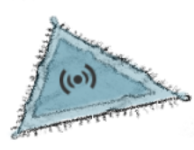
Broadcasting
Throughout the space, you will see blue triangle rugs. These are broadcast spaces. A person standing on a broadcast rug can be seen and heard by everyone in the marked area.
How it works:
- Step on a broadcast rug.
- Wait for a moment. (This is important, otherwise people will only hear half of what you are saying)
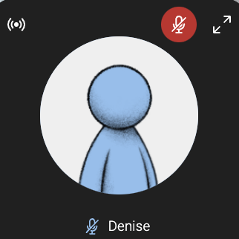
- A small white broadcast icon will pop up in the top left corner of your video screen.
- Now you are broadcasting to everyone in the marked area.
- To end the broadcast, just step off the rug.

Please note:
- Only one person per rug.
- Tell your participants that they have to wait for the broadcast icon before speaking.

Following
When moving from one station to the next, you might want people to follow you so they don´t get lost.
How it works:
- Hover over your video screen.
- Click the “Follow” button that appears on the right.
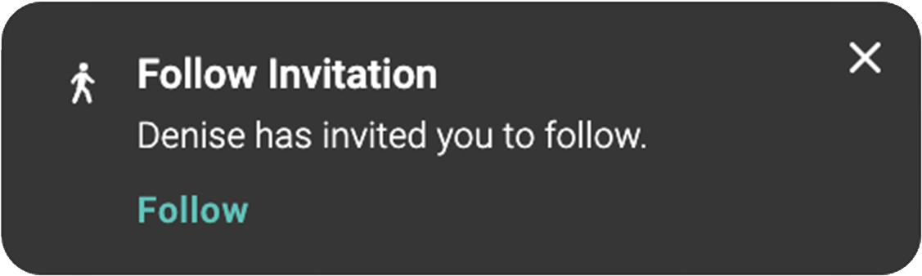
- This will send everyone in your direct proximity a notification on the bottom left of their screen letting them know you would like them to follow you.
- Tell the participants to click on the “Follow” button in their notification.
- Now the group will automatically follow you when you walk.
- To stop the follow, hover over your video screen and click the “Unfollow” button on the right.

Please note: Once people have clicked on the „Follow“ button they should not hit any other button (on the keyboard or with the mouse) or the “Follow” function will stop.

The Menu Bar
On the left side of your screen you will see five icons. Here are their functions:
My Account > Settings
- Controls your audio and video settings which might be important when having sound issues.
Conversations
- Read any messages that have been sent to you.
- Send messages to the anyone in the world or in the private area that you are in.
- To send a private message to someone, look for the message icon in their video box. Once you have exchanged messages with someone in topia, you can stay in touch in the future even if you are not connected via video.
This World
- Here you will find a world map for orientation. The world map is just an image and not interactive.
- The list of „current guests“ shows all people currently present in the world. By clicking on the footprints icon next to a name, you will automatically be walked to this person. This function is very helpful when someone is lost.

More resources to get to know the space: https://resources.topia.io/en/articles/4685987-using-topia

Space Setup
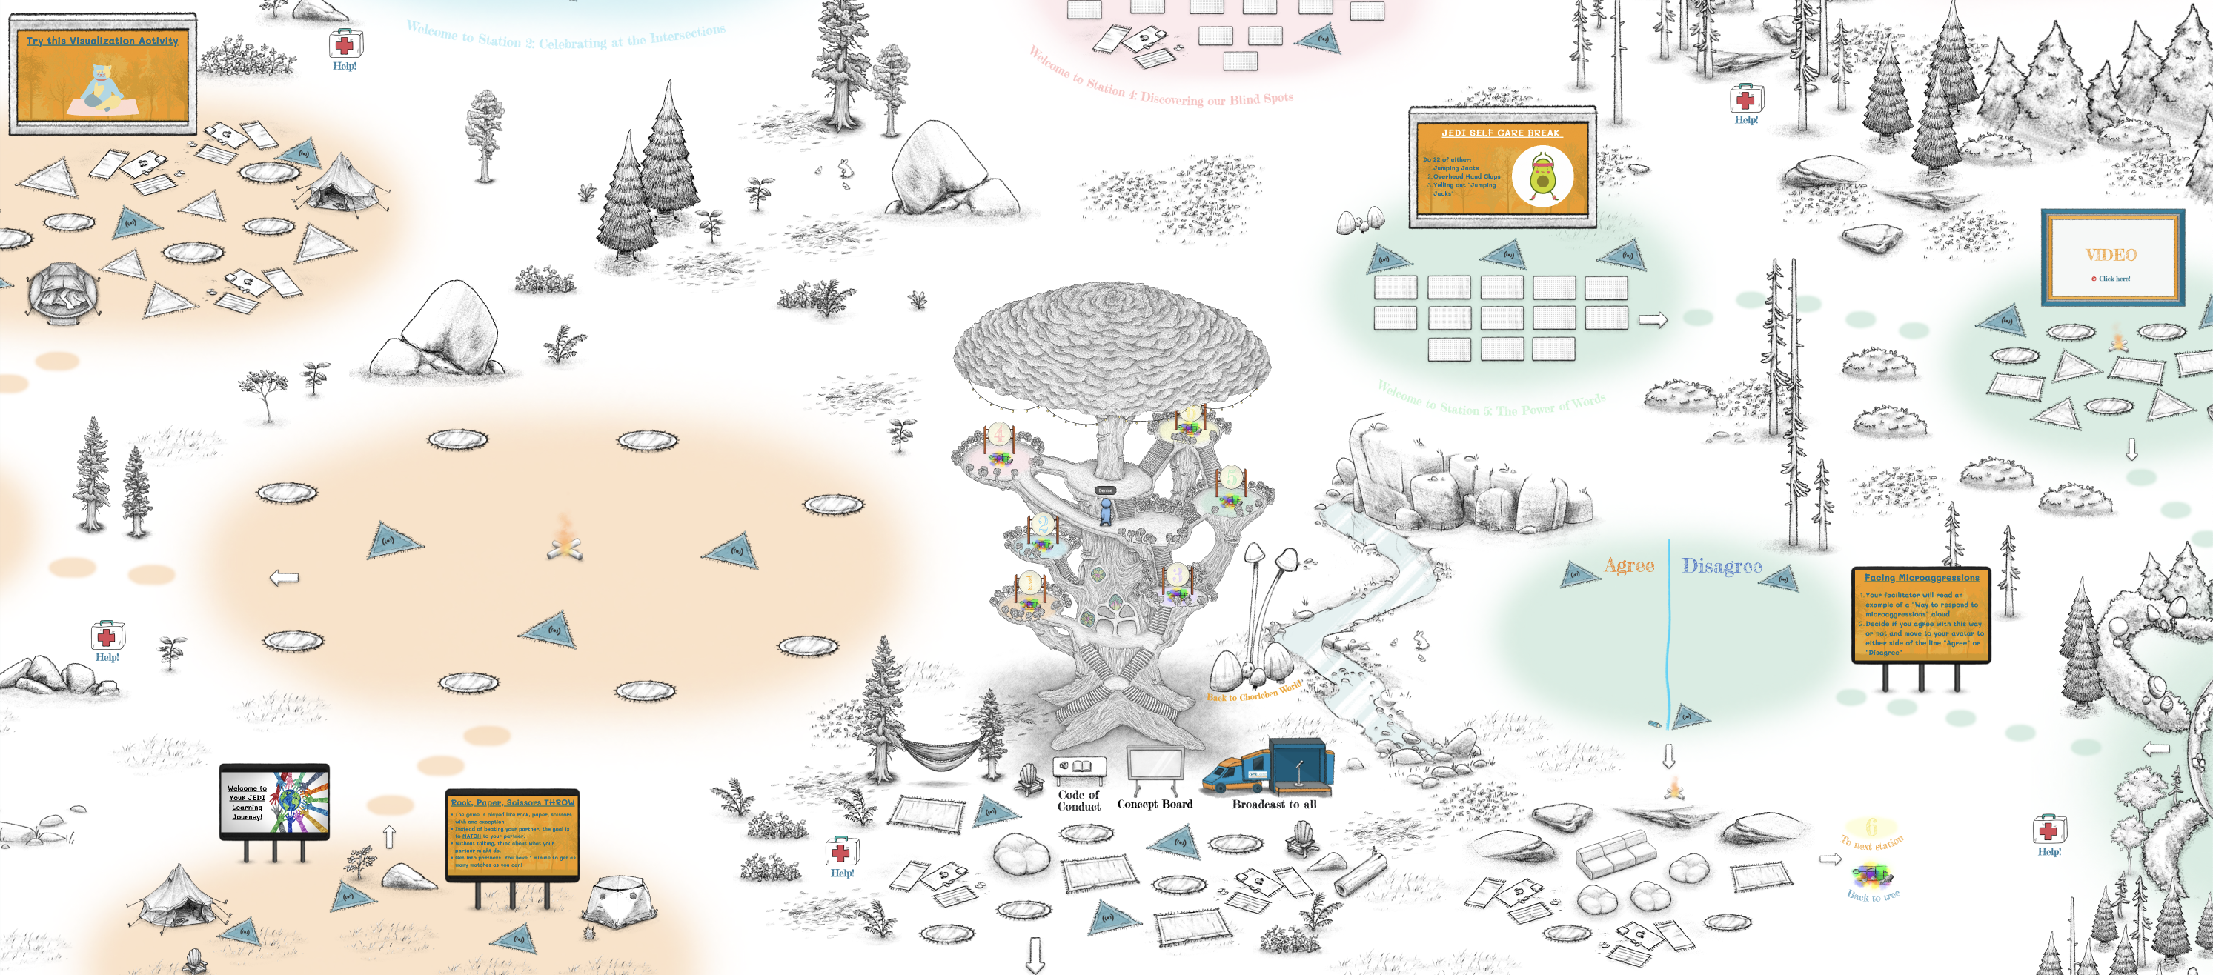
The center of the JEDI learning path is a huge tree. On the platforms located in the tree, there are teleportation loopholes to each station. At the bottom of the tree is a base camp from where you enter the world. This space is made for you to arrive with the group.

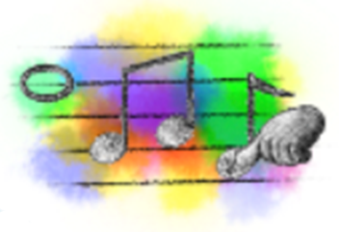
There are 6 stations located in this world. You can zoom out to see all 6 stations, however, the teleportation function on the tree is the fastest way to move to each station.

Stations are color-coded. Colored circles on the ground indicate the correct path to follow.

At the end of each station, you will see a sign that brings you back to the base of the tree or to the next station.

Stations:
- Station 1: Welcome to topia - a JEDI experience
- Station 2: Celebrating at the intersections
- Station 3: Reflecting privilege
- Station 4: Discovering our blind spots
- Station 5: The power of words
- Station 6: Action planning

3. topia Facilitator Tips
Facilitating in topia is great fun! But it‘s also quite different from facilitating live or on Zoom and needs some practice. This chapter will provide you with useful information and tips. But don‘t forget to practice before your first workshop.

Workshop Setup
The JEDI learning path consists of six stations, each of them with a duration of 90 to 120 minutes, depending on group size, engagement, and questions.
We suggest doing the JEDI learning path in a workshop series of six weeks, performing one station per week in small regular workshops. However, feel free to adapt the plan according to your and your groups needs and resources.

Stations:
- Station 1: Welcome to topia - a JEDI experience
- Station 2: Celebrating at the intersections
- Station 3: Reflecting privilege
- Station 4: Discovering our blind spots
- Station 5: The power of words
- Station 6: Action planning

Each station has:
One warm-up activity
Short videos to introduce content
Interactive exercises to reflect, discuss, or exchange in small groups
Action planning

Depending on your experience on the topic and in working with groups feel free to adapt methods and skip or change single tasks.
Please make sure not to skip the action planning in any of the stations 1 thru 6. This is where your group will apply its’ learnings to your choir situation and develop strategies for a more reflective, sensitive, and inclusive choir culture.

Team Setup
Don‘t do the workshops alone. Even if you are very experienced and working with a small familiar group. In topia, it is very likely that at some point at least one participant will need individual support due to technical or user problems and it can be difficult to hold a group together.
We suggest that for each workshop you set up a team of at least two facilitators and one technical support.
Facilitators
- Facilitate the group through the exercises (the next chapter provides detailed instructions).
- Hold the group together, making sure everyone understands and can actively participate.
Technical support
- Watch out if any participants encounter technical problems.
- Explain functions to participants facing problems.
- Monitor and answer the chat.
- Answer the emergency calls.
The technical support needed depends on the number and experience of the participants. For inexperienced groups (e.g. your first workshop with the choir) we recommend one technical support for eight participants. Once everyone is more familiar with topia, you can reduce the support team.

Preparation
First of all, familiarize yourself with the platform. Visit the world with friends or colleagues to prepare yourself and learn about how groups can and can not move around and interact.
Make sure each participant is informed about technical requirements and „first aid“ measures in case of technical problems. Before the workshop, provide the following information:
Prepare yourselves:
- If possible, use the Chrome browser. Chrome provides the best usability for topia.
- Use a headset.
- Do the interactive tutorial „Wie funktioniert topia?” before the workshop.
In case of technical problems:
- Reload the page.
- Check your audio settings.
- Call: xxx [insert your emergency number].
Then check in on your own comfort level with JEDI topics. Most of us have encountered some challenging experiences in this area. So reach out for support in advance to help you face the experience prepared to focus on compassion, respect, and fun.

Technical Troubleshooting
Several bugs may appear, depending on the browser, computer, or settings. Here are some examples:
- Video and sound don‘t pop up when coming closer to others > reload page.
- No sound output (no one can hear you) > check the audio settings in the menu under Settings.
- Someone can‘t follow > just pay attention that you don‘t lose the person.
- Someone can‘t hear the broadcast > reload > if you can‘t find a technical solution, work in groups of max. 10 people without using the broadcast function.
Most problems can be solved by reloading the page. Don’t worry, the participants will come back to the same spot they were on before.
However, you might encounter problems that cannot be solved (due to the technical equipment). Try to find a workaround. You can be creative in troubleshooting, have your whole team participate in this.
It is important to make a maximum effort to allow everyone to participate in the workshop, especially since this is a workshop on JEDI and therefore inclusion.

Hacks for Group Facilitation in topia
Here are things we have learned and hacks that will be useful during your workshops.

Individual experience
For you as a facilitator it is important to understand and keep in mind, that each participant has an individual experience in topia with regard to who they see, what they hear, which media they watch or listen to, and which assets they interact with. You can guide the participants through the workshop and the group activities, but each one of them is responsible for their own experience.

Getting group feedback
When explaining exercises or talking to the group, you will probably be standing on the broadcast rug. In this situation, you will not be able to see most of the participant's videos, which makes it hard to get direct feedback. Here it is helpful to use non-verbal feedback from the group. For example, you can ask the participants:
- to dance if they agree and sit if they do not.
- to sit (or if sitting, to stand up) to show that a task is completed, e.g. watching a video.
- to dance or shout a heart emoji if someone has a question.

Pro tip: Periodically ask if everyone understands everything by making the group dance. Out of habit you will probably ask the group verbally how they are doing and whether they understand everything, but you won´t hear their answers. This can be frustrating for the group as well. It will take some practice as a group to find the best solution to this. Since there are a lot of broadcast rugs everywhere in the world, the group might want to choose a representative who steps onto the broadcast rug and communicates back to the facilitator, should there be any problem.

Timing group work
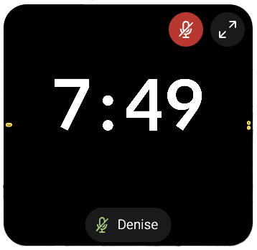
When participants work in smaller groups, set a time limit and announce it before they start. You can even visualize the time by sharing a countdown over your shared screen while standing on a broadcast rug, e.g. this one: https://www.bigtimer.net

Moving with groups
When moving from one place to another with the group, you can:
- use the follow function. Please note, that this might take some practice since everyone has to actively accept to follow.
- walk with one facilitator leading the group, the second one walking at the end of the group to make sure no one gets lost.
- This is particularly important when using teleportation.

Well-being
Be on the lookout for any confusion or clarifications that are needed by participants throughout the experience. Don’t hesitate to take time to answer participants' questions and/or repeat instructions as needed.
Throughout the learning journey, tell your participants, that they are welcome to share as much or as little of their own thoughts and experiences as they like. Some of your participants might have faced discrimination and injustice themselves, therefore it is very important to create an atmosphere where people are sensitive and mindful in their interaction with others.

Time Management
Don‘t rush! The time planned for each station is flexible. Take the time you need to make every participant feel comfortable. Plan extra time for the beginning of the path and when people are new to topia. It takes time to familiarize yourself with the platform.

Relax!
Guiding groups through topia and the workshop will sometimes be a big mess. However, it offers great learning opportunities, enables an individual user (and learning) experience, and lets people interact in a fun way.
This collective experience of learning and growing together in a virtual world is strong and empowering for everyone. So just go for it and have fun.

4. The World

Station 0: Base Camp

(1) Welcome

Objectives: Welcoming and orientation
Approximate time: 10-15 minutes

Facilitator instructions:
- Stand on a broadcast rug
- Welcome
  - Welcome the participants, introduce yourself, the team, and the idea of the workshop.
  - Check in on the well-being of the participants and how much experience they have with topia. Ask them to dance if they agree or sit if they disagree with the following statements:
    - It‘s my first workshop in topia
    - I checked out the “How to topia” learning path before
    - I‘m super excited to be here
    - ....
  - Ask the participants to share questions or thoughts by coming up to the broadcast rug.
- Ask the participants whether they have done the tutorial
- If necessary, share technical instructions
  - How to talk to the group via broadcast rug (be aware that the broadcasts takes a moment to start and that only people in the marked area can hear it)
  - How to mute and unmute yourself
  - How to unmute and mute others
- Introduce the concept board
- Introduce the code of conduct

Note: not far below the base camp is the disco. Here you can come with the groups after the end of your session to finish the workshop.

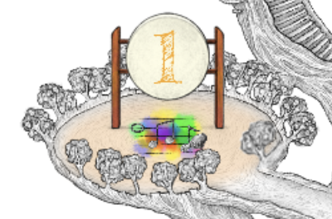
To Station 1!

Station 1: Welcome to topia - A JEDI Experience

Objectives: In this first station, participants will gain an overall understanding of JEDI and why it’s important to learn about it for the well-being of their choir group.
Approximate Time: 90 - 120 minutes

(1) Cooperative rock, paper, scissors
Objective: Warm-up and feel comfortable in the topia space.
Approximate Time: 10-15 minutes
Facilitator Instructions:
- Ask participants to:
  - Team up in pairs and spread out so that they can only see each others video (and the facilitator‘s video; make sure they stay inside the marked area so they can hear the broadcast)
  - Have the video cameras on
- Explain the rules of the exercise:
  - The game is played like rock, paper, scissors with one exception: Instead of beating your partner, the goal is to match your partner.
  - The “rock” sign is a fist, the “paper” sign is your hand open and flat with the palm facing down, and “scissors” is your hand holding a peace sign sideways.
  - Participants are not allowed to say what they will “throw”.
- Do some practice rounds:
  - Ask the participants to “throw” at three.
  - Count out loud for the group “one, two, three”
  - Repeat
  - Ask if there are any questions (non-verbal answer can be dancing).
- Set a timer for one minute and ask the participants to play.
- If time allows, switch partners and repeat

To the next stop!

(2) Group Activity “Speed dating”
Objective: Warm-up and raise awareness for each participant’s individual life circumstances.
Approximate Time: 10-15 minutes
Facilitator instructions:
- Ask the participants to:
  - come together in groups of three and stand on the rugs
  - share as much or as little as they like about the following questions (one at a time)
  - move after each question (one person moves left, one stays, one moves right)
- Set a time limit of three minutes per question.
- Questions:
  - What makes you happy?
  - What makes you angry?
  - What do you believe in?
  - What are your dreams?

To the next stop!

(3) Introduction to JEDI content
Objective: Introduction of the subject of this learning journey.
Approximate Time: 10 minutes
Facilitator Instructions:
- Ask participants to
  - sit down on the pillows in front of the screen
  - “mute” themselves
  - click on the screen. A personal video will pop up for each student to watch individually.
  - stand up once they have finished watching the video

Note: The video does not start at the same time for everyone, it will start when the participant clicks on the icon.

- Video: “Welcome to your JEDI Learning Journey”
- Ask the participants to stand up once they have finished watching the video.
- Check if there are any questions. Don‘t allow discussions about the content at this point.

To the next stop!

(4) Polarization activity
Objectives:
- Raise awareness of personal physical reactions towards positive and negative situations.
- Identify resources and challenges within the choir.
Approximate Time: 45 minutes
Facilitator Instructions:
- Ask participants to get together in small groups of max. four people.

Phase 1: Imagining
- Ask participants to
  - Spread out in the space and sit down (the topi) where they like
  - Close their eyes (the participants)
  - If they feel more comfortable they might switch their camera off.
- Guide them through the first part of the imagining exercise:
  - „Think of a moment when you felt fully appreciated and seen for who you are.“
  - „Get fully present to how this moment feels for you emotionally and physically.“
- Give them a minute or two to really notice what feelings and body sensations are present.

- Guide them through the second part of the imagining exercise:
  - „Think of a moment where you felt judged, misunderstood, and not seen.“
  - „Get fully present to how this moment feels for you emotionally and physically.“
- Again give them a minute or two.

Phase 2: Sharing in small groups
- Ask participants to
  - Get together in small groups of max. four people.
  - Share their experiences as much or as little as you like
- Set a time limit of five minutes for the question:
  - What did you notice physically? If you want, give examples of situations.

Phase 3: Action planning
- Participants stay in their groups.
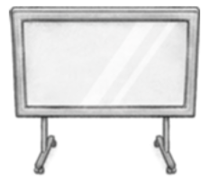
- Ask them to
  - Open the concept board by clicking on the whiteboard asset
(https://app.conceptboard.com/board/gi0p-i4tr-t0uo-2sr5-fn7o)
  - Go to section 1 on the board by zooming in on the section "1: Situations in our choir" in the menu on the left.
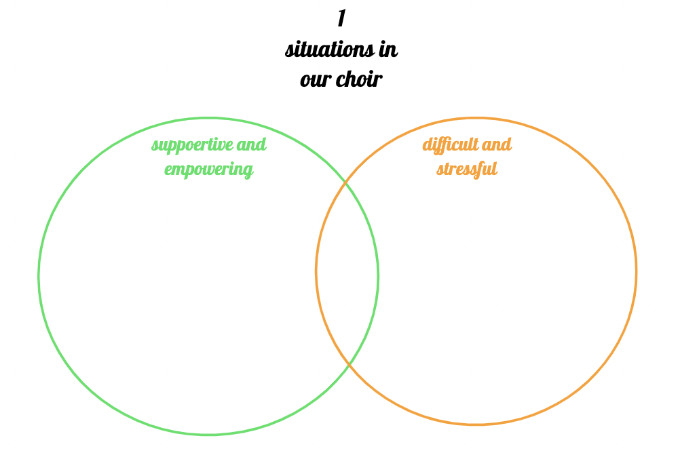
Note: If not yet done, please explain the functions of the concept board, especially how to use Post-Its.
- Set a time limit of 10 minutes for the next task:
  - Reflect about the atmosphere and culture in the choir. Collect situations, which...
    - ...are difficult or stressful <red Post-Its>
    - ... are supportive and empowering <green Post-Its>

- Now ask the participants to read the notes of the other groups and comment on them (on yellow Post-Its), if they want. Set a time limit of 5 minutes.
- Ask the participants
  - if they have any questions.
  - to share conclusions or observations they have made.

Phase 4: Closing
- Explain
  - that it‘s natural for every group to have both positive and challenging situations and patterns. And that it is important to see the positive ones as a resource to deal with internal challenges.
  - that the idea of the workshop is to understand the origin of the problems, work on them, and find solutions.
If you are ending the session:
- Feel free to ask the participants to do some homework until the next session:
  - Look at the board and see if there is something you set out to do? Please write it down for yourself and remember it in your everyday life.
  - Pay attention to your feelings and physical reactions in everyday life situations and encounters. If you like, write them down.

Find the portal to the next station! Behind the billboard you will see a “Blue circle”, this is the teleportation loophole to the next station. Ask participants to click on the blue circle.

Station 2: Celebrating at the Intersections
Objectives: Raise awareness for...
- the interconnected nature of social categorizations such as race, class, and gender.
- how intersectionality can enrich the diversity of thoughts and perspectives
- how the, at times overlapping and interdependent, systems of discrimination or disadvantage also apply to intersectionality.
Estimated Time: 90 - 120 minutes

(1) “Hand Fold” Activity
Objectives:
- Warm-up
- Raise awareness of how our habits influence our perception of well-being.
Estimated Time: 10 minutes
Facilitator Instructions:
- Ask participants to
  - Sit down on the pillows in front of the screen.
  - “mute” themselves.
  - Follow the instructions in the video: Hand Folding Activity
- Click on the screen. A personal video will pop up for each student to watch individually.
Tech Note: The video does not start at the same time for everyone, it will start when the participant clicks on the icon.
- Ask the participants to
  - Come together in pairs.
  - Discuss the following question, set a time limit of 3 minutes:
    - What does this exercise tell you?
- Invite the participants to share their thoughts with the larger group.

To the next Stop!

(2) Introduction to content
Objective: Participants will be....
- familiarized with the basic concept of intersectionality.
- Introduced to different terminologies relevant to this context.
Estimated time: 10 minutes
Facilitator instructions:
- Ask participants to
  - sit down on the pillows in front of the screen.
  - “mute” themselves.
- Introduce the video: “Celebrating at the Intersections” (approx. 3 mins)
  - Click on the screen. A personal video will pop up for each student to watch individually.
Tech Note: The video does not start at the same time for everyone, it will start when the participant clicks on the icon.
- Any questions? (On comprehension only, no discussion) Then transition to next task.
To the next stop!

(3) Group activity “Identity Ripples”
Objectives:
- Raise awareness of different components / ripples of a person‘s identity
- Reflect on the internal and external perception of your own identity
- Contemplate on how you may attribute a certain identity to others.
Estimated time: 20 - 25 minutes
Facilitator Instructions:
- Ask participants to
  - walk around the lily pads and read the different labels on them. Give them 2 minutes to do so.
  - ask them to sit down once they have reviewed the labels.
- Request that each participant chooses (in their mind) 3 Lily Pads that they most identify with.
- Ask participants to
  - stand on one of the Lily Pads they most identify with.
  - repeat three times so that they can move around and stand on three different Lily Pads.
- Now ask participants to
  - gather in small groups of two to three people (find people who are close).
  - share their view on (some of) the questions below.
  - share as much or as little as they like.
- Set a time limit of three minutes for each question (one per person), give six minutes for the last question.
- Questions (you can show the question via screen share, use this presentation: https://slides.com/remix_dcj/identity):
  - Which identities did you choose and why?
  - Do you feel any conflict between your different identities?
  - Do you have any special gifts or insights based on your unique combination of identities?
  - If people were to talk about your identities, which do you think they would choose?
To the next stop!

(4) Understanding “Othering”
Objective: Participants will...
- understand the concept of „othering“.
- Reflect on their own experience with „othering“ in everyday life and the choir.
- Develop ideas to create a culture in the choir, that acknowledges and respects the diversity of its members.
Estimated time: 45 - 75 minutes
Facilitator instructions:
- Ask participants
  - to sit down in the circle.
  - if they would like to share in the group (please go to the broadcast rug):
    - Did anyone learn something about another participant that surprised them?
    - Did that change the image you had of that person?
- Explain the concept of othering:

  - The term othering describes a phenomenon in which some individuals or groups are defined and labeled as not fitting in within the norms of a social group. It is an effect that influences how people perceive and treat those who are viewed as being part of the in-group versus those who are seen as being part of the out-group.
  - Othering also involves attributing negative characteristics to people or groups that differentiate them from the perceived normative social group.
  - It is an “us vs. them” way of thinking about human connections and relationships. This process essentially involves looking at others and saying "they are not like me" or "they are not one of us."
Source: https://www.verywellmind.com/what-is-othering-5084425
- Give space for questions of comprehension and follow-up questions. However, do not enter into the discussion yet, ask the participants to save discussion points for the next step.

Phase 1: Reflection
- Ask them to
  - come together in groups of three to four people and sit down.
  - open the concept board by clicking on it
  - discuss the following questions. Set a five minute time limit for each round.
  - make notes on the concept board during the second round.
- Question 1:
  - If you think about your family, friends, school mates, and other people around you, can you observe “othering”?
  - Can you observe or do you experience “othering” in your choir?
- Question 2:
  - Have a look at the situations / constellations that were noted down last time and identify situations (positive or negative) that are connected to „othering“.
- Ask the participants to read the notes of the other groups and comment on them (on yellow Post-Its) if they want. Ask them to stand up once they have finished.

Phase 2: Action planning
- Ask the participants if they have any questions.
- Ask them to
  - create new groups and sit down.
  - discuss the following questions. Set a time limit of 10 minutes .
  - make notes on the concept board.
- Questions:
  - Which observations and conclusions regarding intersectionality and “othering” did you make in your choir?
  - Which ideas do you have on how you can help each other to work on your implicit biases and how your choir culture could be improved in regard to “othering”?
- Ask the participants to read the notes of the other groups and comment on them (on yellow Post-Its) if they want. Ask them to stand up once they have finished.
- Invite the participants to share their ideas with the larger group.

If you are ending the session here:
- Feel free to ask the participants to do some homework until the next session:
  - Observe situations where you or others might be treated in a special / different way because of your / their (assumed) identities.

Station 3: Privileges
Objectives: Participants will...
- Understand how privileges affect their lives and the lives of others.
- Reflect on the mechanisms of privilege.
- Reflect on privilege and inclusion in their choir.
Estimated time: 90 - 120 minutes

(1) Facing Intersectionality: Perspectives
Objectives:
- Warm up.
- Open the mind for a change of perspective.
Estimated time: 15 minutes
Facilitator instructions:

Phase 1: Warm-up
- Ask participants to
  - sit down on the pillows in front of the screen.
  - “mute” themselves.
  - follow the instructions in the video.
  - click on the screen. A personal video will pop up for each student to watch individually.
  - stand up once they have finished watching the video.
- Video “Perspectives”. All participants watch the video. (approx. 3 minutes).
- Ask the participants to
  - come together in groups of max. three people.
  - discuss the following question, set a time limit of three minutes:
    - “What does this exercise teach you?”
- Invite the groups to share their thoughts with the larger group.

Phase 2: Define Privilege
- Ask the participants to
  - click on the book next to the video screen.
- Read the definition of „privileges“ out loud while everyone follows on their own screens.
- Ask participants to
  - watch the video about „privileges“ until minute 3:13 (the video goes on but the second part is not as relevant for our discussion as the first one).
  - keep their thoughts about the video in mind, there will be time to discuss it.

To the next stop!

(2) Role play: privilege check

Objectives: Raise awareness on how privileges affect your life and the lives of others.
Estimated time: 30 - 45 min
Facilitator Instructions:
Exercise:
- Ask participants to move to the other side of the street.
- Explain the exercise „privilege check“:
  - Eight volunteers take on a role*.
  - Everyone else observes.
  - Each volunteer receives a role card with a small biography that provides information about their life situation.
  - The volunteers gather at the starting line of the road.
  - 15 - 20 statements will be read out loud**
  - The volunteers have to decide for themselves whether the situation applies to their character or not, based on the biography.
  - If it does she*he takes one step forward.
  - If it does not she*he takes one step backward.
  - Those who are not sure what to answer stay where they are.
  - The observers have the task to think about the role of the other participants.
*depending on your group size, you may want to vary the amount of people with roles and the amount of observers. There are 10 roles you can chose from, it is advisable to have a minimum of five people playing in order to make the impact of privileges visible in the game.
** There are 20 questions in the questionnaire. If you have time restraints or feel there are too many questions, you might only want to ask 15 questions and leave out questions #4, #9, #14, #17, and #18.
- Wait until eight volunteers are found.
- Have participants line up at the beginning of the street (before step one).
- Send the biographies to the volunteers via private chat.
- Give the eight participants a short time to read through the biographies (roles must remain secret)
- Read the questions out loud. After each question, give the volunteers a short time to reflect and then make their move or not.

Questions:
- Do you have your own room (or had one when you were younger)?
- Can you go to the movies once per week?
- Can you travel abroad with your family once per year? (holiday as a family, not visiting family)
- Did you attend summer camp as a child?
- If you observed a crime and wanted to report it, would you expect fair treatment from the police?
- Are you (or were you) a member of a club in which you can pursue your interests and for which membership fees are due? (e.g. sports or music club etc.)
- Do you sometimes go to concerts, theater performances, or museums? Did your parents take you there as a child?
- When you have (or had) problems at school, was support organized for you, for example in the form of tutoring?
- Did you achieve your intermediate school-leaving qualification (MSA in Germany) without problems (or is it likely that this will not be a problem)?
- Did you always have a sandwich or healthy snack with you at school?
- Can you kiss your partner in public without reservations?
- Do you feel safe on the street alone after dark?
- Could you get a bank loan? (or your parents if you are under-age?)
- Can you choose where you want to live without limitations?
- Can you (or did you) decide what and where you want to study without limitations?
- Is it easy for you to find an apartment?
- Is it unproblematic for you to invite friends over to your house?
- Do you have more than 50 books in your home?
- Do you feel safe from sexual harassment in school or at work?
- Have you never been insulted because of your group affiliation? (e.g. skin color, nationality, religion, sexual orientation, physical or mental limitations, class, etc.).

Roles:

Simon, 17 years, from Emmerdingen, Germany
You are punk and are currently doing an apprenticeship to become a carpenter. Your father works in construction and your mother as a cashier in a supermarket. You have three younger siblings and always had to share a room with your two brothers. Your parents have always tried to make things possible for you, like summer camps, for example. You even went camping as a family a few times. They also made sure you ate healthy food. Your grades at school were not so good, but you have practical skills, that's why you left school after the 10th grade. You are enjoying your apprenticeship and have even been hired for some extra jobs a few times.

Dilan, 14 years, from Dortmund, Germany
You are in the 8th grade and have a reading and spelling disability. Your mother is unemployed and a single parent, your father left a long time ago. You have no brothers or sisters. In your free time you deliver newspapers to earn some extra money. At school everything is difficult for you and you can hardly wait to leave. You have no real idea what you want to do with your life. Maybe you'd like to become a nurse, but you think that you'll never be able to complete the training anyway.

Mitja, 10 years, from Berlin, Germany
You live with your mother, stepfather, and three other siblings in a three-room apartment in Berlin-Marzahn. You live on welfare and there is often no food for dinner. You are in the 4th grade of an elementary school, have good grades, and dream of becoming a doctor. You like to read, but there are few books at your house and it is often too noisy to concentrate. Sometimes the school janitor allows you to be in the school library a little longer. You have never gone on a class trip because your family can’t afford it. Your mother doesn't know how to apply for support for something like that, and actually she doesn't really care.

Marie, 19 years, Hamburg, Germany
You are in the graduating class of a humanistic high school. You live with your brother and your parents, who are both lawyers, in a single family house on the outskirts of Hamburg. In your free time you enjoy vaulting, singing in the choir, and are involved in the student council. After graduating from high school, you want to volunteer abroad for a year and then perhaps study law or medicine. You have the grades for it and your parents will of course support you financially in your future plans.

Julia, 21 years, Neustrelitz, Germany
You are currently doing a graphic design apprenticeship. You live in a room in a shared apartment with three other people. Your father supports you with 200 Euros each month in addition to your trainee salary. You have little contact with your mother because you came out a few years ago and she does not accept your sexuality. You are the only daughter, your parents are both teachers. You did well in school, but you want to gain some practical experience through the apprenticeship first and then decide later whether you want to study marketing and communications at university.

Christian, 16 years, Briesen, Germany
You are in the 10th grade and live with your parents and your two siblings in a house with a small yard in a small village in Brandenburg. School is an hour away and the bus to the next town only runs twice a day. In your free time you help your parents on the farm, financially you get by, but you can't afford too many extras. Your parents would like you to do an apprenticeship in dairy farming and later work on the farm.

Adil, 26 years, Hannover, Germany
You recently fled to Germany from Homs in Syria with your parents and younger sister. You are currently living in a shelter for refugees. In Syria, you were a prospective math teacher. Your parents both worked as doctors before you had to flee the country. You have a temporary three-year residency permit and are currently taking a B1 German course. You are Muslim and like to paint and draw.

Gülçan, 25 years, Oldenburg, Germany
Your parents immigrated from Turkey, you are devout Muslims. You are employed in a bank and live with your parents. Sometimes you help them in the grocery store after work. Your two brothers no longer live at home. As a young girl, you had little freedom and were rarely allowed to go out. Now that you are grown up, you take your freedom and like to go to the movies or to the café with friends. You would have liked to graduate from high school, but your parents and your teachers were of the opinion that you would not succeed. You then started an apprenticeship in retail, where someone noticed your talent and arranged for you to do a banking apprenticeship. You would actually like to move out, but you can’t secure an apartment despite having a regular income. You have a German boyfriend, but neither your parents nor his parents know anything about your relationship; they would not accept it.

Aidan, 20 years, Munich, Germany
You live in a suburb of Munich, your father is black, African-American, and works as a pilot, your mother is white, German, and works as an editor. You always had good grades and a talent for numbers. Nevertheless, you don't want to go to university, but rather an apprenticeship as a telecommunications technician. Unfortunately, you did not get invited to any job interviews. You are often stopped by the police on the street for no reason, and once you were even briefly arrested because they thought you were a shoplifter.

Valentin, 18 years, from Wismar, Germany
You are in the 12th grade of high school. You have been blind since birth. You manage well with your cane, but in a foreign environment you depend on help from others. You live with your parents, who are always there for you and support you. You read Braille and have a great talent for music. You sing, play the piano by ear, and even compose. You would like to study sound design, but you would have to move to another city. However, you are very introverted and have few friends because you don't seek contact on your own.

Evaluation/reflection:
- Ask participants to stay on the seat cushions on the left side of the street.
- Invite them to share their impressions and observations with the groups.
- first ask the observers
  - What could be the role of those who are at the very back?
  - What could it be for those who are at the very front?
  - And those in the middle?
- First ask the eight volunteers:
  - How did it feel to stay behind or to go ahead?
  - Were you still aware of the others in front of or behind you?
- Ask the eight volunteers to reveal their roles.
- Ask the participants whether they are surprised or not?
- Explain that they will have time to discuss their thoughts and observations in the next step.
To the next stop!

(3) Think Café
Objective:
- Reflect about the mechanisms of privilege
- Reflect about privilege and inclusion in the choir
Estimate time: 40 - 50 min
Facilitator instructions:

Phase 1: Reflection
- Ask the participants to gather around you.
- Explain the setting and the method:
  - On each table you will find a box with questions you can click on.
  - The questions are suggestions, feel free to discuss them or create your own questions.
  - Also remember the input from the video you saw earlier. You might want to include your thoughts on it in the discussion
- Set a time limit of 15 minutes.
- Questions:
  - Which effects of privilege have you already experienced in your everyday life?
  - What factors decide, who receives privileges in a society and who does not?
  - What can more privileged people do to improve life for everyone?
Phase 2: Action planning
- Ask the participants to
  - open the concept board
  - make notes while they discuss the next questions
- Set a time limit of 15 minutes.
- Questions:
  - Is singing in a choir a privilege? For whom? Why?
  - How can our choir be more open and accessible to everybody?
- Ask the participants to read the notes of the other groups and comment on them (on yellow Post-Its) if they want. Ask them to stand up once the have finished.
- Invite the participants to share their observations and ideas in the group.

Station 4: Discovering Our Blind Spots
Objectives: Participants will...
- Learn about implicit biases which are attitudes or stereotypes that we have
- Reflect on how these can affect our understanding, actions, and decisions in an unconscious manner.
Estimated time: 90 - 120 minutes

(1) Open Space JEDI SELF CARE BREAK
Objective: Warm up
Estimated time: 10 minutes
Facilitator instructions:
- Ask participants to
  - sit or stand with shoulders relaxed and back straight (in real life)
  - follow the exercise:
    - Neck - bring your left ear down toward your left shoulder and hold. Roll your head down towards the ground and bring your chin to your chest. Hold and, finally, roll your head to the right and bring that ear to your right shoulder. Inhale and exhale in a slow and controlled manner.
    - Shoulder - stand tall or sit upright. Bring your left arm across your chest, holding it with your opposite arm below the elbow. Keep the shoulders relaxed and away from the ears. Breathe deeply and hold. Repeat on the opposite side.
    - Torso - clasp hands together and slowly raise them above your head toward the ceiling. Reach as high as you can while inhaling deeply and hold for 20-30 seconds. Bring your hands down slowly while exhaling. Be sure to stay relaxed, being mindful of your breathing.

To the next stop!

(2) Introduction to content
Objective: Participants will...
- Learn about implicit bias, stereotypes, prejudice, and discrimination.
- Understand how they are interdependent.
- Get a first idea of how to deal with implicit bias.
Estimated time: 10 minutes
Facilitator instructions:
- Ask participants to
  - sit down on the pillows in front of the screen.
  - “mute” themselves.
  - click on the screen. A personal video will pop up for each student to watch individually.
Tech Tip: The video does not start at the same time for everyone, it will start when the participant clicks on the icon.
- Video: “Discovering Dissonance.” All participants watch the video. (approx. three minutes).
- Any questions? (on comprehension only, no discussion)

To the next stop!

(3) Implicit bias cliff
Objectives: Participants will...
- learn about stereotypes, prejudices, and discrimination
- reflect about the correlations and mechanism between those
[Background: This idea begins with a stereotype. In our brain, we apply the stereotype to a group and give it a negative connotation. That creates a prejudice against that group. If we take this process a step further, we have discrimination. Discrimination incorporates both the stereotype and the prejudice.]
Estimated time: 10 minutes
Facilitator instructions:
- The participants will climb the face of the mountain and stop at each sign. There they will see “Stereotype”, “Prejudice”, and “Discrimination” with definitions.
- Ask the participants to
  - climb the mountain and, along the way, read the definitions.
  - feel free to reflect on their own or share their thoughts with other people.
  - give them five minutes to do so.
- After finishing the walk over the mountain, meet at the circle with the round rugs.

(4) How to be an ally
Objective: Participants will...
- Understand how the implicit bias, othering, sterotypes, prejudice, discrimination, and privilege are interrelated and work together.
- Develop ideas how to be an ally.
Estimated time: 60 min
Facilitator Instructions:
- Explain that there will now be group work and ask participants to listen to the instructions before they break up in groups.

Phase 1: Group work
- Share the concept board on your screen.
- Break up in groups of three to six people, depending on group size (there are five work stations in total).
- Once in the groups, open the concept board and navigate to the flower that has your group number on it.
Note: The concept board will provide a template that helps the participants to analyze with regard to: implicit bias, othering, sterotypes, prejudice, and privilege
- Read the definition of „Ally“ out loud.
- Ask the group to analyze a specific case of discrimination which was shared on twitter by a real person (you will find the case in the center of the flower).
- The groups should think about the described situation and discuss it, fill out the flower petals starting with the privileges of the involved people, then moving to „implicit bias“ and then move on, answering the questions clockwise.
- Set a time limit of 20 minutes for the group work
Phase 2: Gallery walk
Give instructions via the sing-bus of the German Choir Youth asset through „broadcast to all“
- Ask participants to mix up groups in the following way
  - One participant of each group stays at their spot.
  - One participant of each group moves clockwise to the next workspace.
  - One participant of each group moves forward clockwise two workspaces.
  - One participant of each group moves forward clockwise three workspaces.
  - One participant of each group moves forward clockwise four workspaces.

- Invite the participants to have a look at all the cases and answers in the petals and discuss their findings. Ideally each group should have a participant of each case analysis who can present. If that is not not the case, read the notes as a group and discuss:
  - Do you agree with the analysis of the group?
  - Are there additional ideas you would like to add? Feel free to comment.
Set the time limit for the gallery for another 20 minutes

Phase 3: Action planning
- Ask participants to
  - come back to the circle.
  - do the next exercise on their own.
  - reopen the concept board.
  - finish the sentences on Post-Its. They can put as many Post-Its as they like.
Note: the concept board will provide a template with the following questions
- Explain that this exercise is about collecting ideas of how to be an ally.
- Set a time limit of 10 minutes.
- Sentences:
  - "We can all help address different forms of discrimination by....."
  - "We can all make sure everyone in the choir is heard equally by...."
  - "The next time I find myself judging someone due to implicit bias or stereotypes, ...... "
  - "In the next choir rehearsals, I would like to pay special attention to....."

Phase 4: Share
- Invite the participants to share their insights in the group via the three broadcast rugs.
- Give 10 minutes for final discussion.

Station 5: The Power of Words

Objectives: Participants will...
- learn about the power of their words.
- Understand what microaggressions are and how to identify them.
- Develop strategies of how to cope when witnessing them.
Background: Microaggressions are a comment or action that subtly and often unconsciously or unintentionally express a prejudiced attitude toward a member of a marginalized group.
Estimated time: 70 - 100 minutes

(1) JEDI SELF CARE BREAK
Objective: Warm up
Estimated time: 5 minutes
Facilitator Instructions:
- Ask participants to do one of the following together (synchronously):
  - 22 jumping jacks.
  - 22 overhead claps (think jumping jacks, but sitting down).
  - Say “jumping jacks” 22 times.

To the next stop!

(2) Introduction to content
Objective: Participants will learn...
- what microaggressions are.
- why microaggressions are problematic.
Estimated time: 5 minutes
Facilitator instructions:
- Ask participants to
  - sit down on the pillows in front of the screen.
  - “mute” themselves.
  - click on the screen. A personal video will pop up for each student to watch individually.
Tech Note: The video does not start at the same time for everyone, it will start when the participant clicks on the icon.
- Video: “Microaggressions”. All participants watch the video. (approx. three minutes).
- Any questions? (on comprehension only, no discussion)

To the next stop!

(3) Field of statements
Objective: Recognize microaggressions in everyday situations.
Estimated time: 45 - 60 minutes
Facilitator instructions:
- Ask participants to
  - get into groups of three to four people.
  - spread out throughout the space.
  - discuss the following statements and decide which one is a microaggression.
    - if they think it IS a microaggression > stand
    - if they think it IS NOT an microaggression > sit down
(if people disagree, allow immediate discussion)
- Set a time limit of two to three minutes per statement.
- Read one statement out loud at a time.
- Statements:
  - “I have so many __(insert race/ethnicity here)___ friends”
  - “So where are you really from?”
  - Misusing pronouns after a person has stated their preferred pronouns.
  - “Everyone can succeed in society if they work hard enough.”
  - Pronouncing a student’s name incorrectly, even after they have corrected you.
  - “I love languages, do you speak another language?”
  - In an office setting a boss asks an employee to comment on a project that is related to their country of origin. “Is this something you would want to give us information about?”
  - Giving someone a task or role that reinforces particular gender roles.
- Ask participants to
  - stay in their group.
  - share in the group about the following questions. Set a time limit of six minutes per round.
- Questions:
  - What feelings came up for you when listening to the statements? What are your experiences with microaggressions?
  - What impact do you think microaggressions could have in your choir? Which ones do you observe? Which impact does that have?
- Invite the participants to share their insights in the group.

To the next stop!

(4) Facing microaggressions
Objectives: Find strategies to deal with microaggressions.
Estimated time: 15 minutes
Facilitator instructions:
- Explain the exercise:
  - You will read several statements on how to handle microaggressions.
  - After each statement, the participants are asked to move to either side of the line depending on if they agree or disagree with the statement.
- Give them time to reflect and share their point of view with each other.

Note: there is no right answer, in many of these examples context matters.

- Statements:
  - Make sure the person who said the microaggression feels really, really bad and ashamed in front of the group so they never do it again.
  - Avoid talking about microaggressions in your group, it causes too much conflict and it will go away on its own.
  - Ask questions to clarify what was meant when you believe you heard a microaggression and figure out strategies to help challenge preconceived notions, so the class can feel more comfortable and respected.
  - Provide opportunities for all participants to have their voice heard in the group through strategies like providing alternative ways for groups to comment/share and random selection of students.
  - Help students express their feelings in an assertive manner, such as through “I” statements, that include the person’s feelings and the impact of the action/statement on the person.

(5) Microaggression response creator
Objective: Empowerment.
Estimated time: 10 minutes
Facilitator instructions:
- Ask people to come together in groups of three to five people and imagine that you are a bystander and hear a microaggression directed towards another person.
- Explain the exercise:
  - One person in the group reads out a microaggression.
  - Everyone says the response that first comes to their mind.
  - This is not about insulting, but finding creative, quick-witted responses to disarm microaggressions and make the people involved think about it.
  - If you like, you can discuss or continue to the next microaggression.

Note: ask the participants to be sensitive with their words and pay attention to the feelings of everyone. This exercise can be very empowering by leading people to find creative, intelligent, and effective responses to microaggression.

Examples:
- You speak German really well.
- Where are you really from?
- You throw pretty well for a girl.
- You don’t look gay at all.
- You must be good at math (to someone with Asian features).

Station 6: Action Planning

Objective: During this workshop, you have gathered several observations and ideas. This space is for you to use this resource to create additional actions that focus on concrete challenges you want to tackle.
You can do this right after completing the workshop or whenever you are facing (new) challenges.
Estimated Time: 60 - 90 minutes

(1) Recap of the learning path
Objectives: Review the experiences and knowledge learned from the JEDI learning path.
Estimated time: 5-10 minutes
Facilitator instructions:
- Ask participants to
  - sit down on the pillows in front of the screen.
  - “mute” themselves.
  - click on the screen. A personal video will pop up for each student to watch individually.
Tech Note: The video does not start at the same time for everyone, it will start when the participant clicks on the icon.
- Video: “Recap of your JEDI experience” All participants watch the video. (approx. three minutes).
- Any questions? (on comprehension only, no discussion)

(2) Action planning
Objectives: Participants will...
- Analyze concrete challenges they face in the choir related to diversity and inclusion.
- Develop concrete action plans together to make their choir more inclusive.
Estimated time: 45 minutes
Facilitator instructions:
- Ask participants to:
  - come together in groups of three to five people.
  - open the concept board: https://app.conceptboard.com/board/gi0p-i4tr-t0uo-2sr5-fn7o
  - go to the chapter (labeled in German “Abschnitt”) in the menu on the left hand side and choose Station 6: Action planning”; here you will find a template that will guide you through the design of your project.
The following procedure will be repeated for each step on the concept board. Start with the section “What do you want to focus on?“, this one is about the challenge the choir wants to tackle.
- Ask the participants to:
  - create as many sticky notes as they like to get their thoughts on the screen. All the sticky notes should be placed “outside” the text box. Give them one minute to do so.
  - read all of the sticky notes silently to themselves and add or comment if they want. Give them two minutes to do so.
  - discuss in their groups which is the challenge they want to tackle.
  - share their result with the group.
- Facilitate the discussion on choosing a common challenge they want to work on in the big group.
  - If the group can’t decide, feel free to copy the template and let the groups work on different challenges.
  - After having agreed on one common challenge, create one sticky note inside the text box on the screen (or as many as you have topics).

- Repeat this process with each of these sections, in the following order:
  - Where are you at right now regarding the challenge you picked?
  - What is your goal? How do you imagine your choir in one year?
  - What are your supporting resources?
  - What are the obstacles you may encounter?
  - Which steps will take you there?
- Be aware that, of course, for all these questions multiple ideas can be placed in the last step.
- After finalizing all the steps, come back together in the big group and ask the participants to:
  - have a look at the big picture and see whether there is anything missing or anything that does not feel or look right for them.
  - share in the group, discuss, and add those points.
- Now ask the participants how they want to implement their ideas:
  - Is there preparation to be done? Who will be responsible?
  - Do you need regular meetings in order to check in on the progress (e.g. 10 minutes each beginning of choir rehearsals)
  - What can everyone actively do in order to support the implementation of your plan?
  - Plan regular sessions (with the whole choir) to review your plan and adapt it if necessary.
- Once you are clear about your implementation plan, you have finished your action planning

To the next stop!

(3) Disco
Objective: Fun and celebration
Estimated time: as much as you like
Facilitator instructions:
- Ask the participants to follow you to the dance floor.
- Tell them that the workshop is over and they are free to spend time together as they like.

5. Annex

Related links

Who is the Deutsche Chorjugend?

With around 100,000 children and youth in about 2,500 choirs and ensembles - the Deutsche Chorjugend is the largest representation of young choir singers in Germany. As a federal youth association, we are committed to the interests of children and youth who sing. Under the umbrella of the German Choir Association (Deutschen Chorverband) we are organized into regional youth associations. We promote musical and cultural education for young people, participation of children and youth, volunteer work, and international exchange.

www.deutsche-chorjugend.de

Who is mediale pfade?
mediale pfade promotes an emancipatory practice with digital media and new technologies in order to shape an open, just, and solidary society. With contemporary educational formats, we empower people to achieve this goal together with us.
As an association for media education, we see it as our task to accompany educational, training, and research processes in media education. The action-oriented approach is an elementary component of our work and is reflected in our concepts and activities. Special attention is paid to current media developments and their effects on pedagogical action and political and cultural life in our society. We see our work as political education in living environments that are inextricably linked with digital, networked technologies in the 21st century.

www.deutsche-chorjugend.de

Who is Play for Peace?
We are an organization and a global learning community dedicated to developing compassionate leaders in areas of conflict and connecting people and communities to build lasting peace. At Play for Peace, we use play as an experiential and social-emotional learning tool to inspire people from different cultures to reach across barriers and boundaries. Cooperative play is a universal way for people to come together and learn. Youth and adults learn to lead collective experiences where differences are celebrated, friendships are created, and we see what connects us rather than what divides us. When ready, groups then move "beyond play" and begin to include community service learning, effectively solving community issues together.
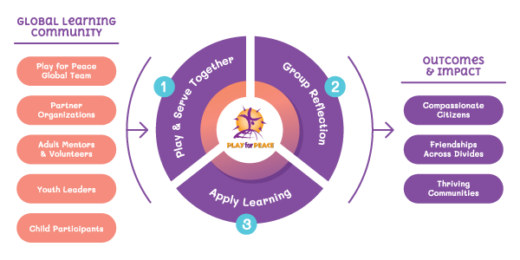
The Play for Peace methodology is integrated into schools, community centers, camps, and local organizations, where local youth leaders are trained to conduct "Practice Peace" cooperative play sessions for younger children and “Beyond Play” community service projects that benefit entire neighborhoods. Using cooperative activities, Play for Peace Programs change young lives, educate children, and transform communities, specifically:
★ Creating safe environments in which people of all ages can experience the joy of play.
★ Promoting positive relationships among people of societies in conflict.
★ Fostering leadership for peace around the world.
★ Building self-sustaining learning communities in which all of our regions work interdependently to build a more peaceful world.
www.playforpeace.org

